CarePath: An Online Disease/Healthcare System
CPS731 Team 1
Veezish Ahmad (501080184)
Jessica Morcos (501093695)
Barbod Salehiporva (501120154)

Table of Contents
0 Pre-PhaseI: Software Project Management Plan (SPMP)
0.1 Gantt Chart (excel format)
0.2 Team Organization and Management
1 Phase-I: Requirements Analysis
1.1 Discuss about System Domain & Objectives
1.2 Define System Major Actors/Components
1.3 Glossary
1.4 Table of Functional Requirements (FR)
1.5 Table of Non Functional Requirements (NFR)
1.6 Table of Assumptions (A)
1.7 Table of Responsibilities (R)
1.8 Table of Use Cases (UC)
1.9 Use Case Diagrams (UCD)
1.10 Use Case Scenarios (STD)
1.11 Activity Diagrams (AD)
1.12 Traceability (initial)
2 Phase-II: System Design
2.1 Apply Fixes on Phase-I
2.2 Class Diagram (initial)
2.3 Discuss and Apply selected Design Pattern(s)
2.4 Class Diagram (update)
2.5 Updated Sequence Diagrams (USD)
2.6 Traceability (update)
3 Phase-III & IV: System Implementation & Testing
3.1 Implementation of System Objects (coding)
3.2 Implementation of System UIs (coding)
4.1 Test Plan & Test Cases with Sample Results

CarePath: An Online Disease/Healthcare System
Pre-Phase 1 & Phase 1
CPS731 Group 1
Veezish Ahmad (501080184)
Jessica Morcos (501093695)
Barbod Salehiporva (501120154)

Team Organization

Role | Team Member | Core Responsibilities | Key Deliverables / Tasks (per Gantt Chart) | Project Phases
Project Manager | Veezish | Oversees project planning, schedule tracking, cost estimation, and deliverable submission. Ensures consistency between requirements, design, and implementation. | Methodology & Initial Planning (1.1), Functional/Non-Functional Requirements (1.2), Class & Sequence Diagrams (1.6), Apply Design Patterns (2.1), Slides & Demo (3.2.2) | Pre-Phase I → Phase IV
System Designer / Backend Developer | Barbod | Designs system architecture, integrates backend components, performs unit testing and debugging. | Draft SPMP (1.1.1), Requirements Docs (1.4), Integrate Components (2.4), Unit Tests & Debugging (3.1), System Demos (3.2.1) | Phase I → IV
UI/UX & Requirements Engineer | Jessica | Develops user interface and manages requirements documentation. Designs use cases and actors for clarity. | Use Cases & Actors (1.3), Define Classes & Attributes (1.5), Develop UI (2.3), Project Documentation (3.2) | Phase I → IV
Quality Assurance & Testing Coordinator | All Team Members | Conducts validation testing, compiles final report, and ensures compliance with objectives. | Final Testing & Validation (4.1), Final Report Compilation (4.2), Final Demo & Presentation (4.3) | Phase IV

Table of Contents
0 Pre-PhaseI: Software Project Management Plan (SPMP)
0.1 Gantt Chart (excel format)
0.2 Team Organization and Management
1 Phase-I: Requirements Analysis
1.1 Discuss about System Domain & Objectives
1.2 Define System Major Actors/Components
1.3 Glossary
1.4 Table of Functional Requirements (FR)
1.5 Table of Non Functional Requirements (NFR)
1.6 Table of Assumptions (A)
1.7 Table of Responsibilities (R)
1.8 Table of Use Cases (UC)
1.9 Use Case Diagrams (UCD)
1.10 Use Case Scenarios (STD)
1.11 Activity Diagrams (AD)
1.12 Traceability (initial)

Pre-PhaseI: Software Project Management Plan (SPMP)

0.1 Gantt Chart (excel format)
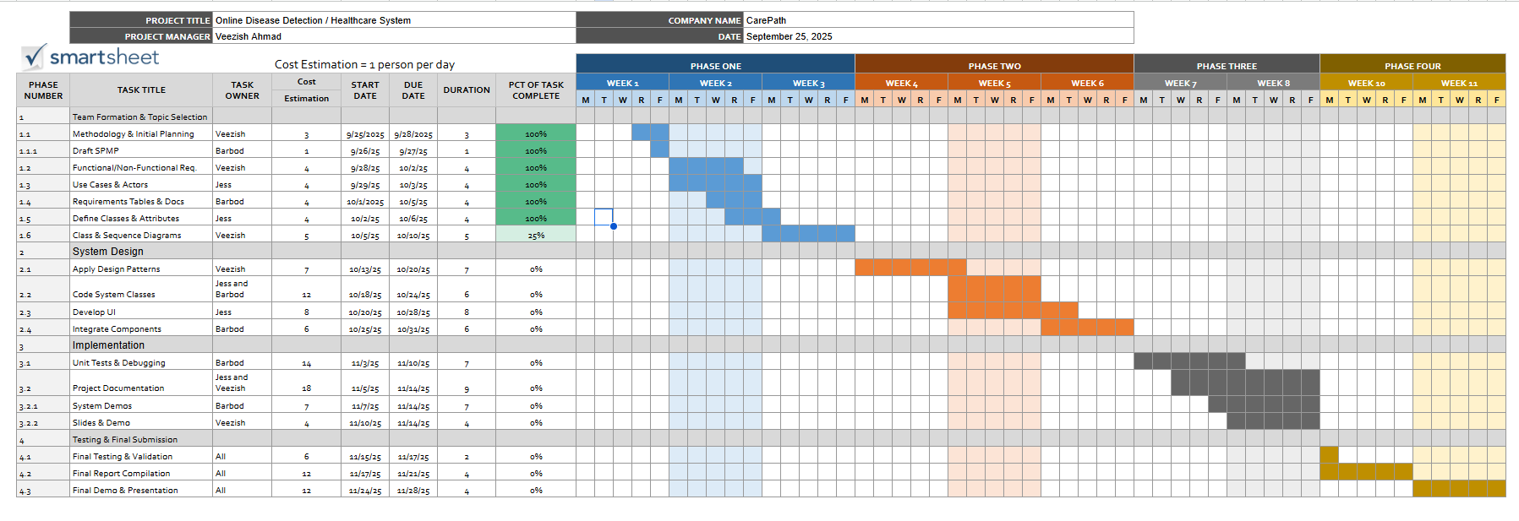

0.2 Team Organization and Management

Team Organization

Role | Team Member | Core Responsibilities | Key Deliverables / Tasks (per Gantt Chart) | Project Phases
Project Manager | Veezish | Oversees project planning, schedule tracking, cost estimation, and deliverable submission. Ensures consistency between requirements, design, and implementation. | Methodology & Initial Planning (1.1), Functional/Non-Functional Requirements (1.2), Class & Sequence Diagrams (1.6), Apply Design Patterns (2.1), Slides & Demo (3.2.2) | Pre-Phase I → Phase IV
System Designer / Backend Developer | Barbod | Designs system architecture, integrates backend components, performs unit testing and debugging. | Draft SPMP (1.1.1), Requirements Docs (1.4), Integrate Components (2.4), Unit Tests & Debugging (3.1), System Demos (3.2.1) | Phase I → IV
UI/UX & Requirements Engineer | Jessica | Develops user interface and manages requirements documentation. Designs use cases and actors for clarity. | Use Cases & Actors (1.3), Define Classes & Attributes (1.5), Develop UI (2.3), Project Documentation (3.2) | Phase I → IV
Quality Assurance & Testing Coordinator | All Team Members | Conducts validation testing, compiles final report, and ensures compliance with objectives. | Final Testing & Validation (4.1), Final Report Compilation (4.2), Final Demo & Presentation (4.3) | Phase IV

Management Parameters

Parameter | Description | Alignment with Gantt Chart
Leadership & Coordination | The Project Manager (Veezish Ahmad) leads planning and progress tracking meetings every two days to maintain alignment with Gantt milestones. | Reflected in Tasks 1.1 and 3.2 (Planning & Documentation).
Task Allocation | Tasks are divided according to individual strengths and technical roles. Responsibilities mirror the actors defined in Phase I (use case mapping). | Gantt Tasks 1.1 – 3.2.2 show member ownership for each module .
Communication Plan | Regular updates via Microsoft Teams and shared Google Drive. Major decisions logged in the SPMP document. | Ongoing through Weeks 1 – 11 of Gantt.
Progress Monitoring | Weekly status reports reviewed against Gantt Chart timeline. Progress percentages tracked per task (25%–100% completion). | Gantt shows incremental progress values (e.g., Class Diagrams 25%) .
Quality Assurance | Each phase includes internal reviews before submission. Unit tests and final validation (Phase III–IV) ensure alignment with FR/NFR and STD tables. | Tasks 3.1 & 4.1.
Risk & Change Management | Contingency buffer built into Phase II–III for design iteration. Change requests logged in SPMP and approved by Project Manager. | Week 6–10 of Gantt (Design and Integration phase).
Documentation Control | Versioning handled through Google Docs and GitHub. Documentation Lead (Jess) consolidates Phase Reports and SPMP sections. | Task 3.2 (Project Documentation).

Phase I: Requirements Analysis

1.1 System Domain and Objectives
System Domain:
The Online Disease Detection / Healthcare System is part of the healthcare informatics domain. It integrates artificial intelligence and databases to support patients and healthcare providers. The system allows patients to input symptoms, medical history. The AI engine processes this input and produces likely disease predictions along with recommended next steps. Structural aspects include the user interfaces (patient portal, doctor portal, admin dashboard), a secure database, and an AI engine. Behaviorally, the system interacts in real time with users, enabling early intervention and providing decision support for medical professionals.
Objectives:
- Provide patients with accessible, AI-assisted preliminary disease detection.
- Improve early diagnosis and intervention to reduce healthcare costs and risks.
- Ensure secure storage, management, and exchange of medical data.
- Comply with regulations (HIPAA/PHIPA) and maintain trustworthiness.
In Scope:
- Patient registration and authentication.
- Symptom input and AI-based disease prediction.
- Secure storage and retrieval of electronic health records (EHR).
- Doctor access to patient data and predictions.
- Administrative functions for user management and compliance enforcement.
Out of Scope:
- Direct medical treatment or prescription services (system is an advisory tool, not a replacement for a licensed physician).
- Hospital management functions such as pharmacy logistics, billing, or scheduling.
- Emergency medical services requiring real-time intervention.

1.2 System Major Components/Actors

Major Component / Actor | Responsibilities & Roles
Patient | Inputs symptoms, views results, communicates with doctor
Doctor | Reviews patient data, confirms/adjusts predictions, consults with patients
AI Engine | Analyzes inputs, generates disease predictions
Database | Stores encrypted medical data, patient history, and system logs
Admin | Manages users, oversees compliance and maintenance
System | Manages authentication, session control, request routing, error handling, and communication

1.3 Content of the Current Document and Glossary
All diagrams, tables and items in this document should have been assigned identifiers. The # symbol indicates a unique number for each member of a given category.

Category | Identifier
Use Case | UC#
Assumption | A#
Functional Requirements | FR#
Non Functional Requirements | NFR#
Scenario Textual Description | STD#
Sequence Diagram | SD#
Activity Diagrams | AD#
Class Diagrams | CD#
Test Case | TC#

1.4 Table of Functional Requirements (FR)

Patient

FR ID | Description | Traceability
FR01 | The system shall allow patients to register/login securely. | UC01, STD01, AD01, R01, R08, R25, R28, R33, NFR03, NFR06, A01, A02, A06
FR02 | The system shall allow patients to input symptoms. | UC02, STD02, AD02, R02, R03, R06, R07, R22, R25, NFR01, NFR04, A01, A03
FR03 | The system shall send alerts for abnormal readings to patients. | UC03, STD03, AD03, R06, R23, NFR01, A01
FR04 | The system shall allow patients to review AI predictions. | UC03, STD03, AD03, R04, R20, R23, NFR01, A07
FR05 | The system shall allow patients to update or correct previously entered data. | UC02, STD02, AD02, R07, R25, R32, NFR01, A03
Doctor
FR ID | Description | Traceability
FR06 | The system shall allow doctors to view and edit patient reports. | UC04, STD04, AD04, R09–R13, R25, R28, R32, NFR03, NFR02, A04
FR07 | The system shall allow doctors to annotate predictions with comments/notes. | UC04, STD04, AD04, R11, R12, R25, NFR03, A04
FR08 | The system shall alert doctors when predictions are flagged as low confidence. | UC03, UC04, STD03, STD04, AD03, AD04, R23, R14, R25, NFR01, A04, A07
FR09 | The system shall maintain longitudinal patient data for trend analysis. | UC04, UC05, STD04, STD05, AD04, AD05, R09, R13, R25, R32, NFR02, A05
FR10 | The system shall allow doctors to report incorrect predictions/system issues. | UC04, UC06, STD04, STD06, AD04, AD06, R14, R38, R39, A04, NFR02

AI Engine

FR ID | Description | Traceability
FR11 | The system shall generate possible disease predictions. | UC03, STD03, AD03, R17–R20, R23, NFR01, NFR05, A03, A07
FR12 | The AI Engine shall continuously learn and refine predictions from new data. | UC03, STD03, AD03, R18, R21, NFR01, A03
FR13 | The AI Engine shall detect anomalies or incomplete data. | UC02, STD02, AD02, R22, R25, NFR01, A03
FR14 | The AI Engine shall flag low-confidence predictions for doctor review. | UC03, STD03, AD03, R23, R14, R11, A04, A07, NFR01
FR15 | The AI Engine shall ensure predictions are generated within response time limits (< 2s). | UC03, STD03, AD03, R18, R24, NFR01, A01, A05

Database

FR ID | Description | Traceability
FR16 | The system shall store and retrieve patient health records in a structured format to support secure access by authorized users. | UC05, STD05, AD05, R25, R27, R32, A05, A06
FR17 | The Database shall store AI outputs (e.g., draft notes, summaries, recommendations) and reference the source request ID. | UC05, STD05, AD05, R25, R29, A05
FR18 | The system shall record all database operations (create, read, update, delete) in an audit log accessible to Admin for review. | UC05, UC06, STD05, STD06, AD05, AD06, R29, R35, R36, NFR03, A06
FR19 | The Database shall store AI generation requests (prompts, parameters) with a unique request ID. | UC05, STD05, AD05, R25, R27, R31, A05, A09
FR20 | The system shall retrieve and deliver patient data to front-end users upon valid request. | UC04, UC05, STD04, STD05, AD04, AD05, R25, R32, A05

Admin
FR ID | Description | Traceability
FR21 | The system shall allow the Admin to create, modify, and deactivate user accounts. | UC01, UC07, STD01, STD07, AD01, AD07, R33, R34, NFR03, A08
FR22 | The system shall allow the Admin to assign appropriate access rights (role-based). | UC07, STD07, AD07, R34, R28, R37, NFR03, A08
FR23 | The system shall allow the Admin to monitor compliance with healthcare regulations (HIPAA/PHIPA). | UC06, STD06, AD06, R35–R37, NFR03, A06
FR24 | The system shall allow the Admin to conduct audits of system activity. | UC06, STD06, AD06, R36, R29, R35, NFR03, A06
FR25 | The system shall allow the Admin to generate compliance and audit reports. | UC06, STD06, AD06, R36, R41, R29, NFR03, NFR02, A09
FR26 | The system shall allow the Admin to apply patches, updates, and upgrades to maintain availability. | UC06, STD06, AD06, R39, R40, R41, NFR02, A09

System
FR ID | Description | Traceability
FR27 | The system shall validate and route all incoming user requests to the correct component (AI, DB, or Admin). | UC01–UC07, STD01–STD07, AD01–AD07, R43, R44, NFR03
FR28 | The system shall manage session control and authentication tokens to prevent unauthorized access. | UC01, UC07, STD01, STD07, AD01, AD07, R45, R46, NFR03
FR29 | The system shall ensure synchronization between front-end interfaces and backend databases. | UC02, UC03, UC05, STD02, STD03, STD05, AD02–AD05, R43, R47, NFR02
FR30 | The system shall handle internal errors and provide user-friendly error messages without exposing sensitive data. | UC01–UC07, STD01–STD07, AD01–AD07, R48, R49, NFR03
FR31 | The system shall log all transactions, activities, and data exchanges for auditability. | UC05-UC07, STD05-STD07, AD05–AD07, R49, NFR03
FR32 | The system shall enforce access control policies between patients, doctors, and admins. | UC01, UC04, UC07, STD01, STD04, STD07, AD01, AD04, AD07, R50, NFR03
FR33 | The system shall maintain consistent uptime by handling exceptions and failover mechanisms. | UC06, UC07, STD06, STD07, AD06, AD07, R51, NFR02

1.5 Table of Non-Functional Requirements (NFR)

ID | Description | Traceability
NFR01 | System response time ≤ 2 s (p95) for predictions and data retrieval. | FR02, FR03, FR08, FR11, FR14, FR15, FR20, UC02, UC03, STD02, STD03, AD02, AD03, R18, R19, R20, R24, R32, A01, A05
NFR02 | System availability ≥ 99.5%; nightly automated backups; Recovery Point Objective (RPO) ≤ 24 h; Recovery Time Objective (RTO) ≤ 4 h; documented restore tests. | FR09, FR19, FR25, FR26, FR33, UC05, UC06, UC07, STD05, STD06, STD07, AD05–AD07, R27, R31, R39, R40, R41, R51, A05, A09
NFR03 | The system must comply with HIPAA / PHIPA requirements for privacy, consent, and access logging. | FR01, FR06, FR16, FR17, FR18, FR22, FR23, FR24, FR25, FR28, FR30–FR32, UC01, UC04, UC05, UC06, UC07, STD01, STD04–STD07, AD01, AD04–AD07, R15, R26, R28, R29, R34–R37, R45, R46, R49, R50, A06, A04
NFR04 | The system supports a multilingual interface. | FR01, FR02, UC01, UC02, STD01, STD02, AD01, AD02, R01, R02, A02
NFR05 | The system can handle up to 10,000 concurrent users. | FR11, FR15, FR33, UC03, UC05, UC06, STD03, STD05, STD06, AD03, AD05, AD06, R24, R30, R52, A05
NFR06 | All PHI shall be encrypted at rest (AES-256) and in transit (TLS 1.2 +). Keys are managed through an approved KMS with periodic rotation and auditing. | FR01, FR16, FR17, UC01, UC05, UC06, STD01, STD05, STD06, AD01, AD05, AD06, R26, R29, NFR03, A06

1.6 Table of Assumptions (A)

ID | Description | Traceability
A01 | Patients have access to a stable internet connection to use the system effectively. | UC01, UC02, UC03, STD01–STD03, FR01, FR02, FR03, FR15, FR20, NFR01, R01, R02, R24
A02 | Users (patients/doctors) own a compatible device (smartphone, tablet, or PC) to run the application. | UC01, UC02, UC04, STD01, STD02, STD04, FR01, FR02, FR06, NFR04, R01, R02
A03 | Symptom and medical history data provided by patients is accurate and truthful. | UC02, UC03, STD02, STD03, FR02, FR11, FR12, FR13, R02, R03, R06, R22
A04 | Doctors using the system are licensed professionals who provide valid feedback. | UC04, STD04, FR06, FR07, FR08, FR10, FR14, NFR03, R09–R16
A05 | Cloud hosting services remain operational with minimal downtime. | UC01–UC07, STD01–STD07, FR09, FR15, FR16, FR19, FR20, FR33, NFR01, NFR02, NFR05, R27, R30, R31, R39, R51
A06 | The system has the necessary approvals to comply with healthcare data protection regulations (HIPAA/PHIPA). | UC05, UC06, UC07, STD05–STD07, FR01, FR16, FR17, FR18, FR23–FR25, FR26, NFR03, NFR06, R26, R35, R37, R29, R34
A07 | Patients understand that the system provides advisory predictions only and is not a replacement for medical treatment. | UC03, STD03, FR04, FR11, FR14, NFR01, R04, R23
A08 | Adequate budget and time will be available to complete the system according to the project plan. | All UC, All FR, All NFR, FR21, FR22, UC07, STD07, AD07, R33–R37, R42
A09 | No major external system failures (e.g., power outages, cyberattacks) will completely halt the service. | UC06, UC07, STD06, STD07, FR19, FR25, FR26, FR33, NFR02, R39, R40, R41, R51

1.7 Table of Responsibilities

Responsibilities of the Patient
ID | Responsibility | Traceability
R01 | Register, log in, and manage personal profiles.. | UC01, STD01, AD01, FR01, FR21, NFR03, NFR04, A01, A02, A06
R02 | Enter symptoms for analysis. | UC02, STD02, AD02, FR02, FR13, NFR01, NFR04, A01, A03
R03 | Upload medical history and updates when necessary. | UC02, STD02, AD02, FR02, FR13, A03
R04 | View AI-generated predictions. | UC03, STD03, AD03, FR04, FR11, FR14, NFR01, A07
R05 | Review past reports and history stored in the system. | UC04, STD04, AD04, FR06, FR09, FR16, NFR02, A05
R06 | Provide accurate input to ensure reliable predictions. | UC02, STD02, FR02, FR03, FR13, A03
R07 | Update or correct data if the system requests validation. | UC02, STD02, AD02, FR02, FR05, FR13, NFR01
R08 | Log out securely after each session. | UC01, STD01, AD01, FR01, FR28, NFR03

Responsibilities of the Doctor

ID | Responsibility | Traceability
R09 | Log in securely with verified credentials. | UC01, UC04, STD01, STD04, AD01, AD04, FR01, FR06, FR21, NFR03, A04
R10 | Access patient records and AI predictions. | UC04, STD04, AD04, FR06, FR20, NFR03, A04
R11 | Validate, correct, or expand AI predictions with professional judgment. | UC04, STD04, AD04, FR06, FR07, FR14, NFR03, A04
R12 | Add comments, notes, or recommendations to patient records. | UC04, STD04, AD04, FR06, FR07, FR09, NFR03
R13 | Review historical data for longitudinal analysis. | UC04, STD04, AD04, FR06, FR09, FR16, FR20, NFR02
R14 | Report potential system errors or incorrect predictions. | UC04, UC06, STD04, STD06, AD04, AD06, FR10, FR11, FR18, A04, NFR02
R15 | Maintain confidentiality of patient data. | UC04, UC05, STD04, STD05, AD04, AD05, FR06, FR16, FR17, NFR03, A04, A06
R16 | Use the system consistently to support continuous improvement of AI accuracy. | UC03, UC04, STD03, STD04, AD03, AD04, FR11, FR12, A04

Responsibilities of the AI Engine

ID | Responsibility | Traceability
R17 | Retrieve patient symptoms and history from the database. | UC03, STD03, AD03, FR11, FR16, FR20, NFR01
R18 | Process input data using machine learning algorithms. | UC03, STD03, AD03, FR11, FR12, FR15, NFR01, NFR05
R19 | Generate predictions with confidence levels. | UC03, STD03, AD03, FR11, FR14, NFR01, NFR05
R20 | Deliver results to the user interface. | UC03, STD03, AD03, FR04, FR11, NFR01
R21 | Continuously learn and refine predictions based on new data. | UC03, STD03, AD03, FR11, FR12, A03
R22 | Detect anomalies or incomplete data. | UC02, STD02, AD02, FR02, FR13, A03
R23 | Flag low-confidence predictions for doctor review. | UC03, STD03, AD03, FR03, FR08, FR11, FR14, NFR01, A07
R24 | Ensure predictions are generated within response time limits. | UC03, STD03, AD03, FR11, FR15, NFR01, NFR05, A01, A05

Responsibilities of the Database

ID | Responsibility | Traceability
R25 | Store and retrieve patient records securely. | UC01, UC02, UC04, UC05, STD01–STD05, AD01–AD05, FR01, FR02, FR05, FR06, FR09, FR16, FR20, NFR03
R26 | Encrypt all sensitive patient health information. | UC05, UC06, STD05, STD06, AD05, AD06, FR16, FR17, FR18, NFR03, NFR06, A06
R27 | Backup data regularly to prevent loss. | UC05, STD05, AD05, FR16, FR19, FR26, NFR02, A05
R28 | Manage access controls for different system roles. | UC01, UC04, UC07, STD01, STD04, STD07, AD01, AD04, AD07, FR06, FR22, FR32, NFR03
R29 | Maintain audit logs for accountability. | UC05, UC06, UC07, STD05–STD07, AD05–AD07, FR16, FR18, FR24, FR25, NFR03, A06
R30 | Support scalability for concurrent access. | UC01, UC02, UC03, UC05, STD01–STD05, AD01–AD05, FR11, FR15, NFR05, A05
R31 | Restore data quickly in case of system failure. | UC05, UC06, STD05, STD06, AD05, AD06, FR19, FR25, FR26, NFR02, A05, A09
R32 | Optimize storage for efficient retrieval. | UC04, UC05, STD04, STD05, AD04, AD05, FR06, FR09, FR16, FR20, NFR01

Responsibilities of the Admin

ID | Responsibility | Traceability
R33 | Create and manage user accounts. | UC01, UC07, STD01, STD07, AD01, AD07, FR01, FR21, NFR03, A08
R34 | Assign appropriate access rights (patient, doctor, staff). | UC07, STD07, AD07, FR22, FR32, NFR03, A08
R35 | Monitor compliance with healthcare regulations (HIPAA/PHIPA). | UC06, STD06, AD06, FR23, FR24, FR25, NFR03, A06
R36 | Conduct regular audits of system activity. | UC06, STD06, AD06, FR23, FR24, FR25, NFR03, NFR02, A06
R37 | Enforce data privacy and security policies. | UC06, STD06, AD06, FR23, FR24, FR25, NFR03, A06
R38 | Resolve reported technical/system issues. | UC06, STD06, AD06, FR10, FR26, NFR02, A09
R39 | Maintain uptime and ensure system availability. | UC06, UC07, STD06, STD07, AD06, AD07, FR26, FR33, NFR02, A09, A05
R40 | Apply patches, updates, and upgrades to the system. | UC06, STD06, AD06, FR26, NFR02, A09
R41 | Respond to and document incidents (e.g., cyberattacks, downtime). | UC06, STD06, AD06, FR25, FR26, NFR02, A09
R42 | Train users and provide support for proper system use. | UC01, UC02, UC04, STD01–STD04, AD01–AD04, FR01, FR02, FR06, A08

Responsibilities of the System
ID | Responsibility | Traceability
R43 | Coordinate communication between all components and ensure workflow execution (e.g., Patient → AI Engine → Database). | UC02, UC03, UC05, STD02, STD03, STD05, AD02, AD03, AD05, FR27, FR29, NFR03
R44 | Validate incoming data and enforce consistent formatting before passing to backend modules. | UC02, STD02, AD02, FR27, FR29, NFR03, A03
R45 | Handle authentication requests and generate session tokens. | UC01, UC07, STD01, STD07, AD01, AD07, FR28, FR33, NFR03
R46 | Implement timeout, logout, and re-authentication mechanisms for secure access. | UC01, UC07, STD01, STD07, AD01, AD07, FR28, NFR03, A01
R47 | Maintain state consistency between AI predictions and database updates. | UC03, UC05, STD03, STD05, AD03, AD05, FR29, FR32, NFR02
R48 | Capture and handle exceptions gracefully with appropriate user-side alerts. | UC01–UC07, STD01–STD07, AD01–AD07, FR30, NFR03
R49 | Maintain detailed transaction and access logs for auditability and traceability. | UC05, UC06, UC07, STD05–STD07, AD05–AD07, FR31, NFR03, NFR06, A06
R50 | Apply access control rules (RBAC) ensuring each role’s permissions are respected. | UC07, STD07, AD07, FR32, FR22, NFR03, A08
R51 | Monitor uptime and initiate failover to backup services during downtime. | UC06, UC07, STD06, STD07, AD06, AD07, FR33, FR19, NFR02, A05, A09
R52 | Scale requests dynamically under heavy system load. | UC03, UC05, STD03, STD05, AD03, AD05, FR35, FR33, NFR05, A05

1.8 Table of Use Cases (UC)

ID | Name | Description | Sub-Goals | Traceability
UC01 | Register/Login | Patient creates an account, logs in securely, and manages profile settings. | Validate user credentials  - Allow new user registration  - Encrypt and store authentication details  - Provide password recovery/reset  - Enforce session management (logout, timeout) | FR01, FR21, FR28, STD01, AD01, R01, R08, R09, R25, R28, R33, R45, R46, R50, NFR03, NFR04, NFR06, A01, A02, A06
UC02 | Enter Symptoms | Patient inputs symptoms and uploads medical history for analysis. | - Input symptoms via structured fields  - Upload past medical history  - Validate completeness/format of data  - Store securely in database  - Confirm successful submission | FR02, FR05, FR13, STD02, AD02, R02, R03, R06, R07, R22, R25, R44, NFR01, NFR04, A01, A03
UC03 | Generate Prediction | AI Engine analyzes inputs and generates possible disease predictions. | - Retrieve patient input from database  - Analyze symptoms using AI/ML  - Generate predictions with confidence levels  - Display results clearly to patient  - Flag low-confidence results for doctor review | FR03, FR04, FR08, FR11, FR12, FR14, FR15, STD03, AD03, R04, R16, R17, R18, R19, R20, R21, R23, R24, R43, R44, R47, NFR01, NFR05, A03, A04, A07
UC04 | View Patient Reports | Doctor accesses patient history, AI predictions, and updates records. | - Retrieve records, symptoms, and predictions  - Display historical patient reports  - Enable doctor edits/annotations  - Save corrections/notes  - Maintain version history | FR06, FR07, FR08, FR09, FR10, FR20, STD04, AD04, R09, R10, R11, R12, R13, R14, R15, R16, R25, R28, R32, R42, NFR03, NFR02, A02, A04, A05
UC05 | Store Health Records | Database securely stores and encrypts patient information and predictions. | - Encrypt health information  - Store in compliance with HIPAA/PHIPA  - Maintain audit logs of data actions  - Enable efficient record retrieval  - Backup/restore to ensure reliability | FR09, FR16, FR17, FR18, FR19, FR20, STD05, AD05, R25, R26, R27, R29, R30, R31, R32, R43, R47, NFR03, NFR05, NFR06, A05, A06
UC06 | Manage Compliance | Admin monitors system activity, ensures compliance, and manages users. | - Admin monitors system logs  - Conduct PHIPA/HIPAA audits  - Detect/respond to security incidents  - Apply updates/patches  - Generate compliance reports | FR10, FR18, FR23, FR24, FR25, FR26, STD06, AD06, R35, R36, R37, R38, R39, R40, R41, R49, R51, NFR02, NFR03, NFR06, A06, A09
UC07 | Manage User Accounts | Allow Admin to create, modify, or deactivate accounts. | - Add new patient/doctor accounts  - Modify account details  - Reset credentials  - Deactivate inactive accounts  - Enforce role-based access | FR21, FR22, FR32, STD07, AD07, R28, R33, R34, R35, R37, R39, R42, R45, R46, R50, NFR03, NFR02, A08

1.9 Use Case Diagram (UCD)

Login/Register
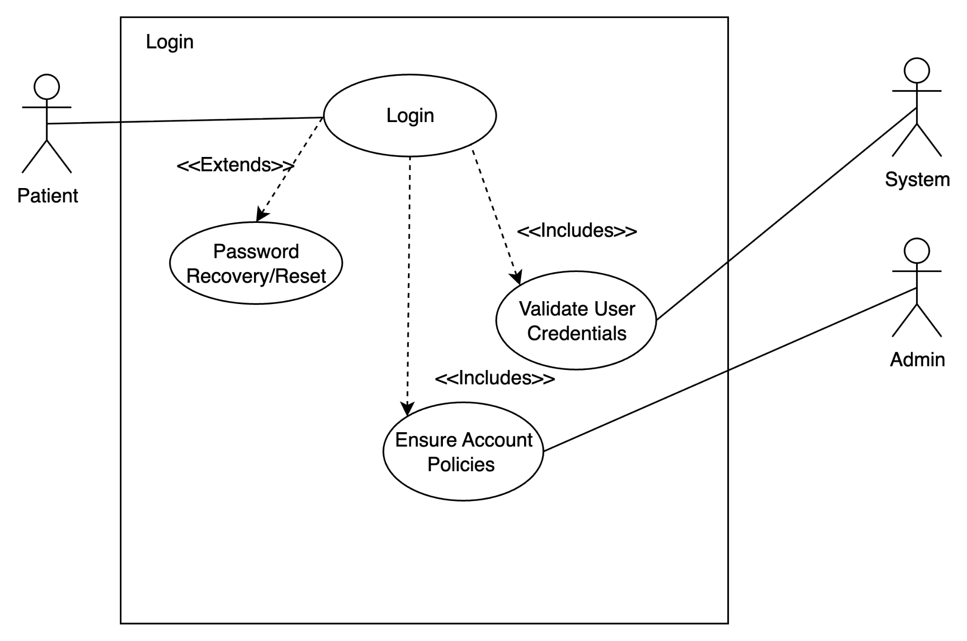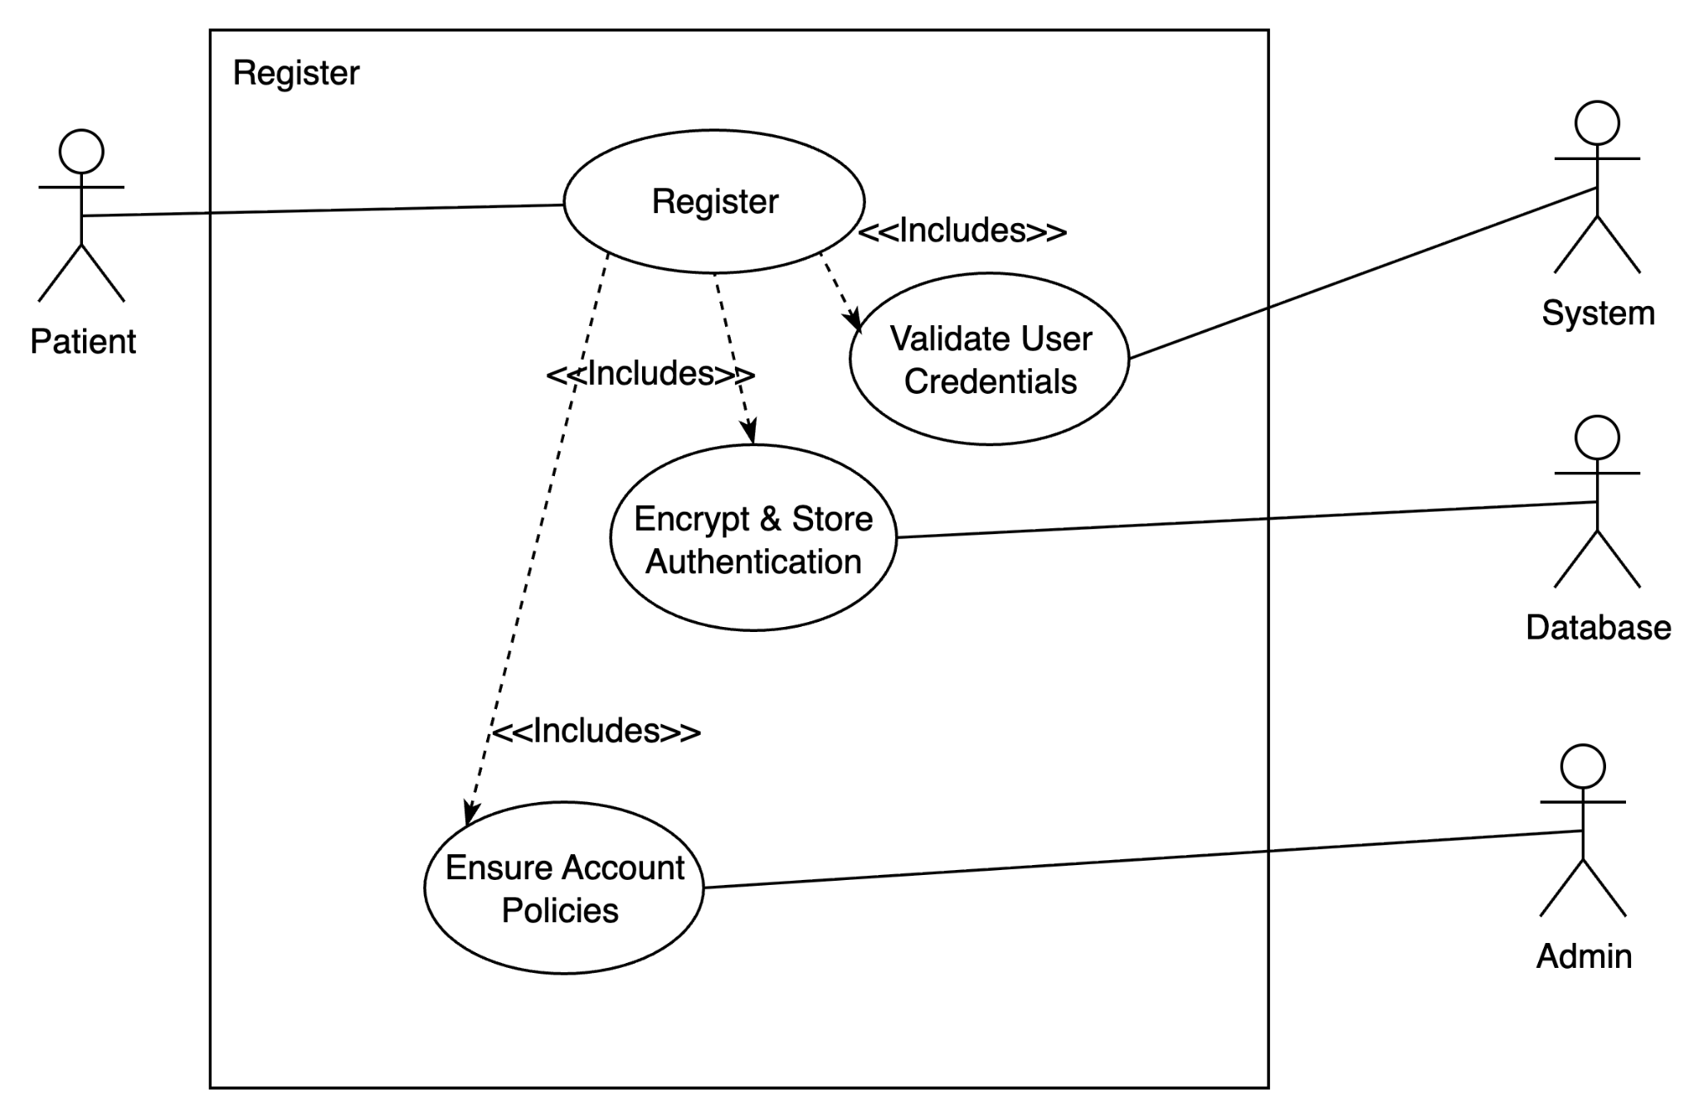

Enter Symptoms
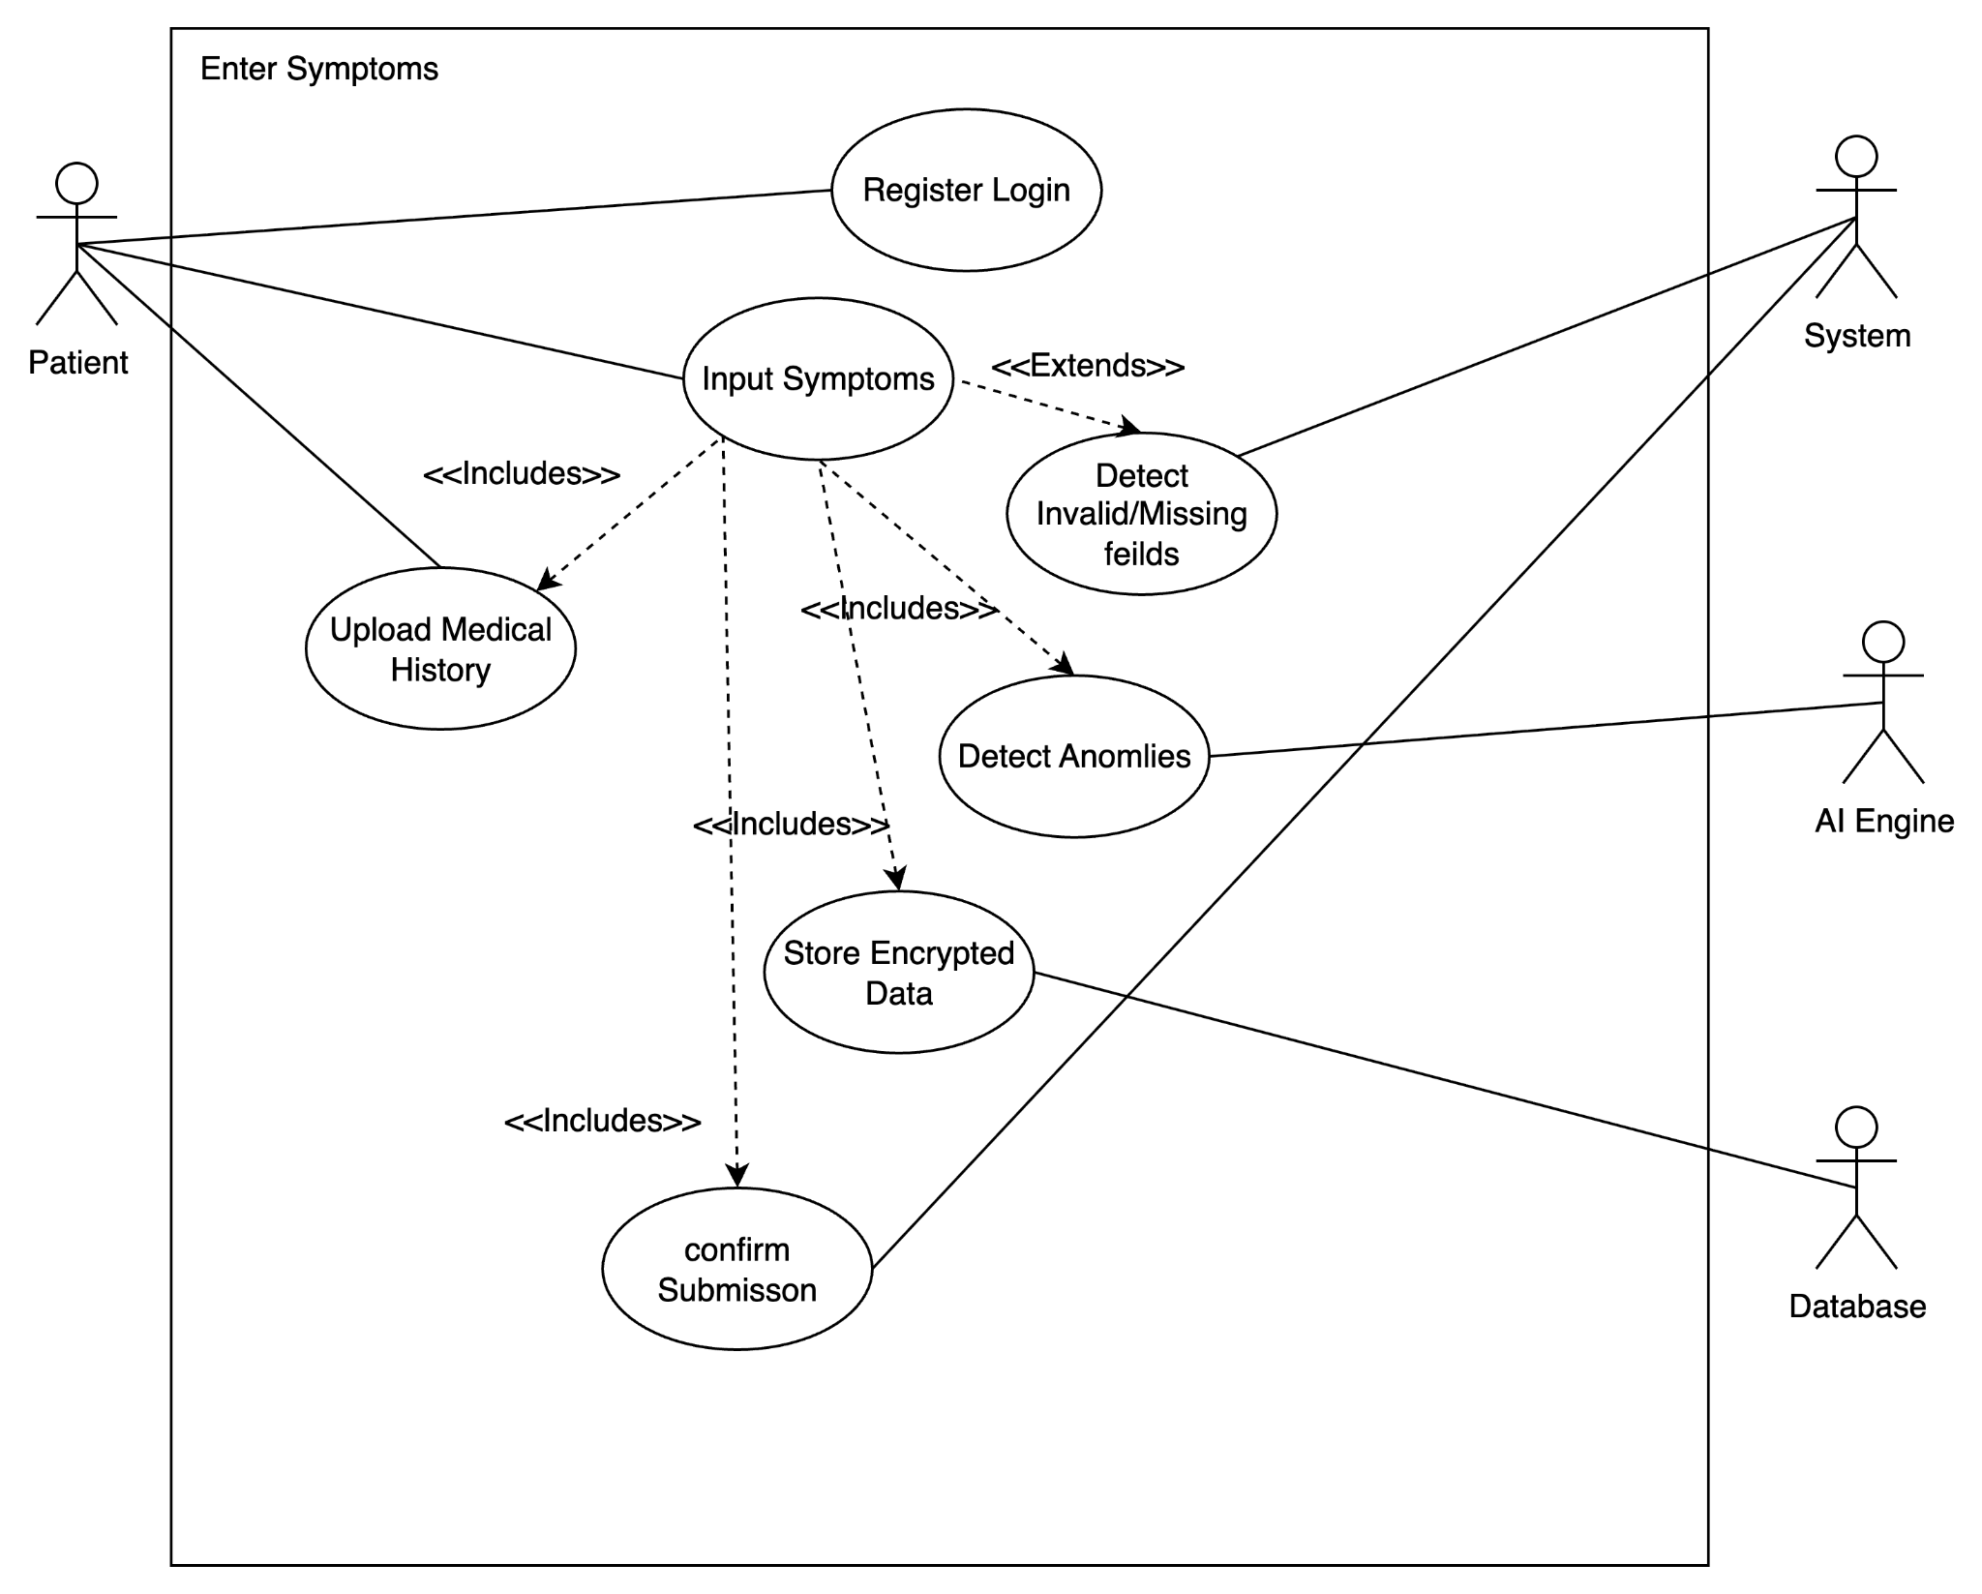

Generate Prediction
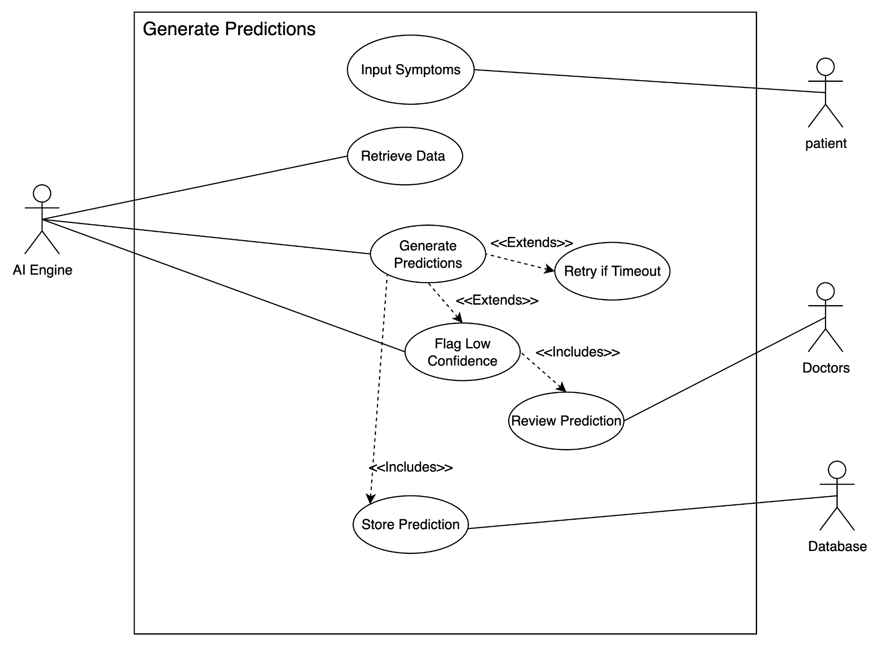

View Patient Reports
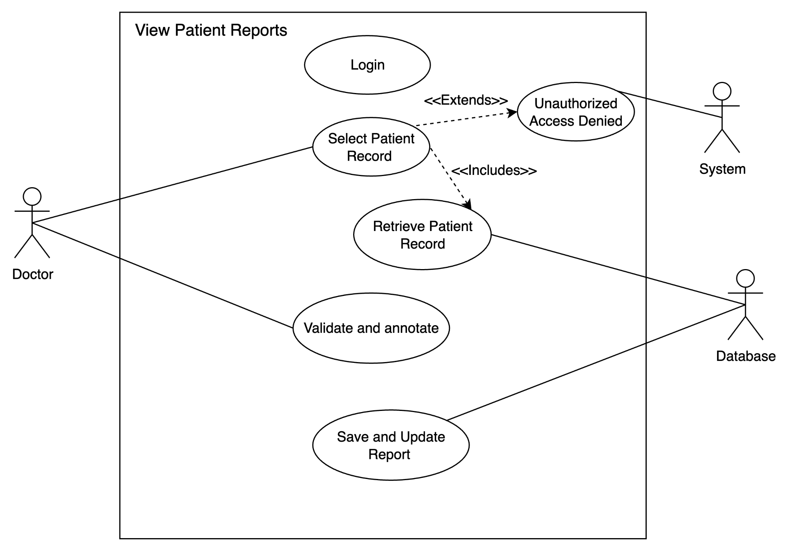

Store Health Records
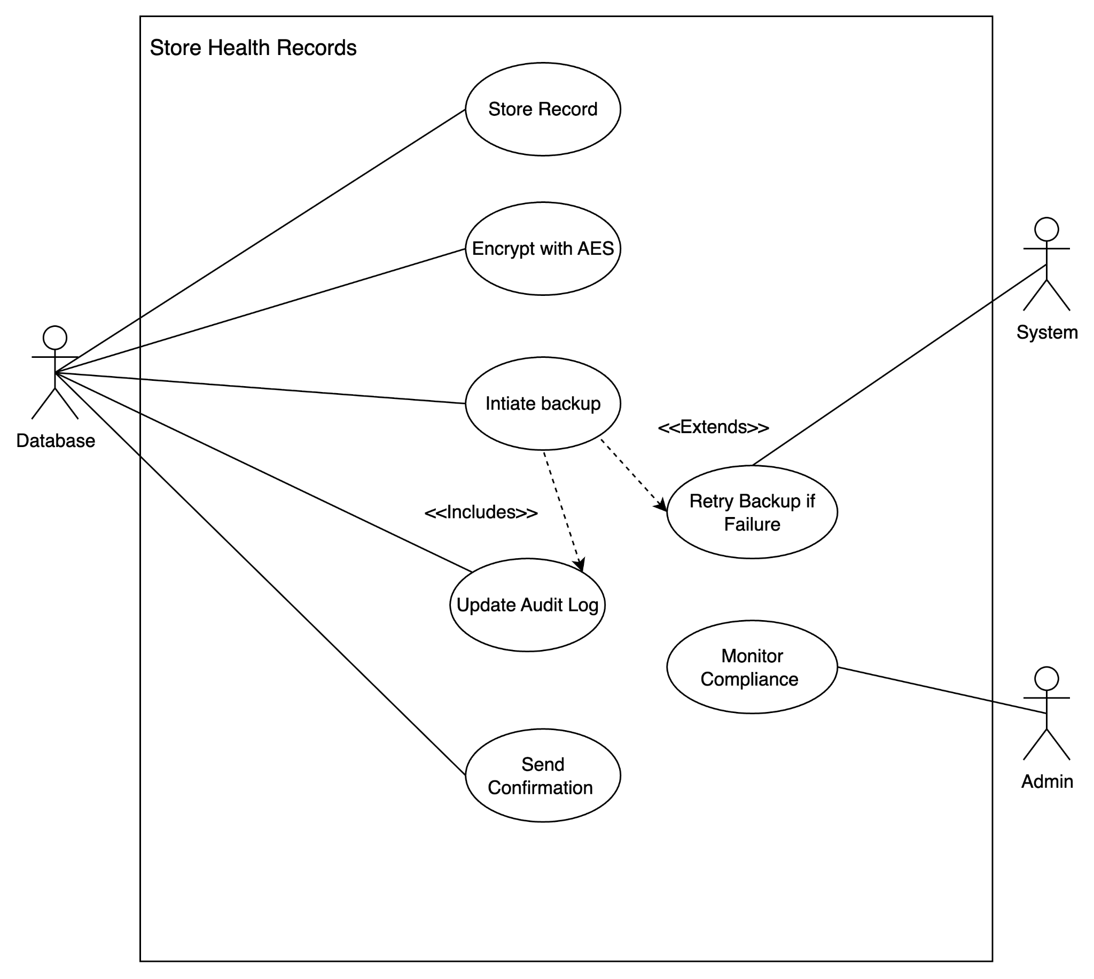

Manage Compliance
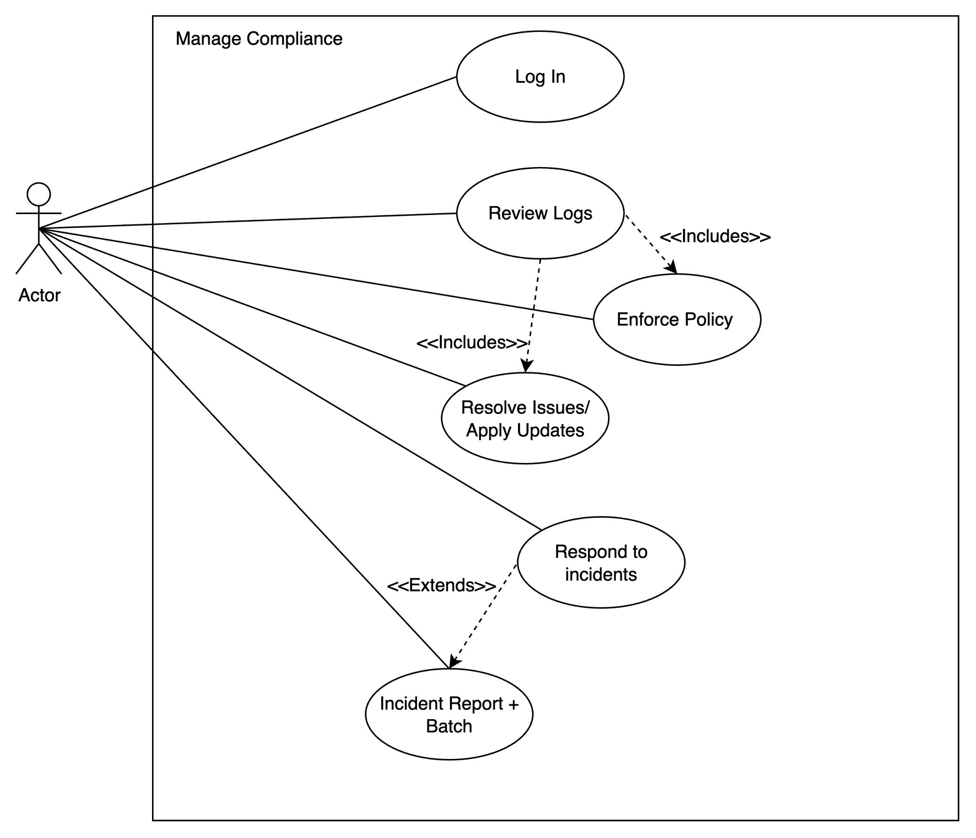
Manage User Accounts
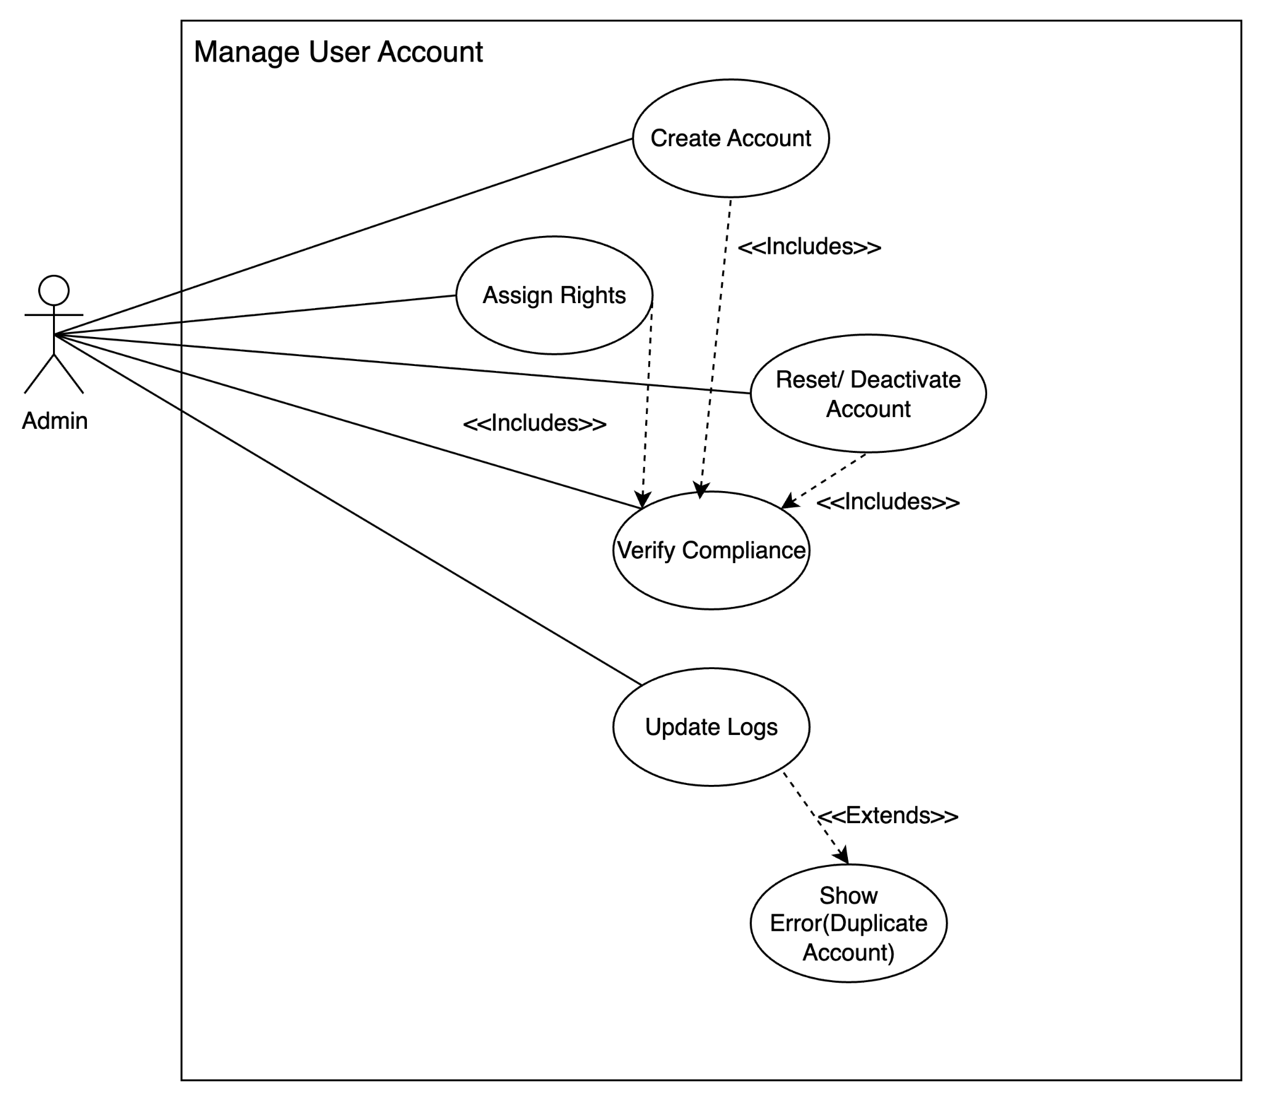

1.10 Scenario Textual Descriptions (STD)

STD01: Register/Login (UC01)

Field | Description
Scope & Description | Patient registers or logs into the system securely.
Primary Actor | Patient
Stakeholders & Interests | Patient: wants secure access.  System: must validate and encrypt credentials.  Admin: ensures compliance.
Precondition | Patient has device + internet connection.
Trigger | Patient selects “Register” or “Login.”
Main Scenario Steps | 1. (R01) Patient provides login details.  2. System validates input.  3. (R25) DB retrieves/creates account record.  4. (R33) Admin ensures account policies.  5. Patient enters dashboard.
Postcondition | Patient logged in successfully.
Extensions | Invalid login → retry prompt. Forgotten password → recovery option.

STD02: Enter Symptoms (UC02)

Field | Description
Scope & Description | Patient inputs symptoms and medical history.
Primary Actor | Patient
Stakeholders & Interests | Patient: easy input.  Doctor: depends on reliable data.  System: secure storage.
Precondition | Patient is logged in (UC01).
Trigger | Patient selects “Enter Symptoms.”
Main Scenario Steps | 1. (R02) Patient inputs symptoms.  2. (R03) Uploads history.  3. (R22) AI detects anomalies.  4. (R25, R26) DB stores encrypted data.  5. System confirms submission.
Postcondition | Symptoms stored in DB for analysis.
Extensions | Missing/invalid fields → correction prompt.

STD03: Generate Prediction (UC03)

Field | Description
Scope & Description | AI Engine analyzes patient data and generates predictions.
Primary Actor | AI Engine
Stakeholders & Interests | Patient: wants timely results.  Doctor: reviews for accuracy.  System: ensures compliance.
Precondition | Symptoms stored in DB (UC02).
Trigger | Patient submits data for analysis.
Main Scenario Steps | 1. (R17) AI retrieves data.  2. (R18, R19) Processes input and generates predictions.  3. (R23) Flags low-confidence cases.  4. (R20) Sends results to UI.  5. (R25) Stores prediction in DB.
Postcondition | Predictions displayed + stored.
Extensions | Timeout → retry. Low confidence → doctor review.

STD04: View Patient Reports (UC04)

Field | Description
Scope & Description | Doctor reviews patient records and AI predictions.
Primary Actor | Doctor
Stakeholders & Interests | Doctor: complete and accurate data.  Patient: expects reliable interpretation.
Precondition | Doctor logged in (UC01).
Trigger | Doctor selects patient record.
Main Scenario Steps | 1. (R09) Doctor logs in.  2. (R10) Requests file.  3. (R25, R28) DB retrieves record.  4. (R11, R12) Doctor validates/annotates.  5. System saves updates.
Postcondition | Report updated and stored.
Extensions | Unauthorized access → denied.

STD05: Store Health Records (UC05)

Field | Description
Scope & Description | Database stores encrypted health data.
Primary Actor | Database
Stakeholders & Interests | Patient: data privacy.  Doctor: reliable retrieval.  Admin: compliance.
Precondition | New data submitted by patient or AI.
Trigger | System sends data to DB.
Main Scenario Steps | 1. (R25) DB stores record.  2. (R26) Encrypts with AES-256.  3. (R27) Backup initiated.  4. (R29) Audit log updated.  5. Confirmation returned.
Postcondition | Data securely stored.
Extensions | Backup failure → retry.

STD06: Manage Compliance (UC06)

Field | Description
Scope & Description | Admin oversees compliance and audits.
Primary Actor | Admin
Stakeholders & Interests | Admin: ensures regulations.  Users: trust system protection.
Precondition | Admin authenticated.
Trigger | Admin selects compliance dashboard.
Main Scenario Steps | 1. (R33) Admin logs in.  2. (R35, R36) Reviews logs.  3. (R37) Enforces policies.  4. (R38–R40) Resolves issues, applies updates.  5. (R41) Responds to incidents.
Postcondition | Compliance maintained.
Extensions | Breach detected → incident report + patch.

STD07: Manage User Accounts (UC07)

Field | Description
Scope & Description | Admin creates, modifies, or deactivates accounts.
Primary Actor | Admin
Stakeholders & Interests | Admin: manages accounts.  Users: expect security.
Precondition | Admin authenticated.
Trigger | Admin opens user management panel.
Main Scenario Steps | 1. (R33) Create account.  2. (R34) Assign rights.  3. (R35, R37) Verify compliance.  4. Reset or deactivate accounts.  5. (R36, R39) Update logs.
Postcondition | Accounts updated.
Extensions | Duplicate account → error prompt.

1.11 Activity Diagrams (AD)

AD01: Register/Login (UC01)
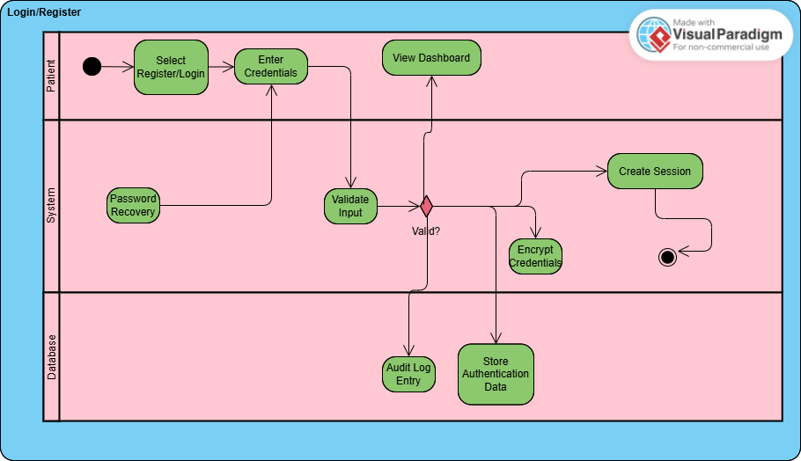

AD02: Enter Symptoms (UC02)
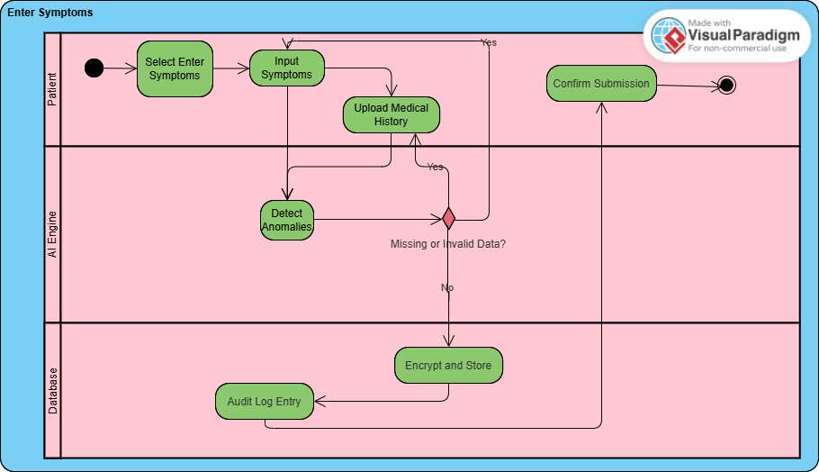

AD03: Generate Prediction (UC03)
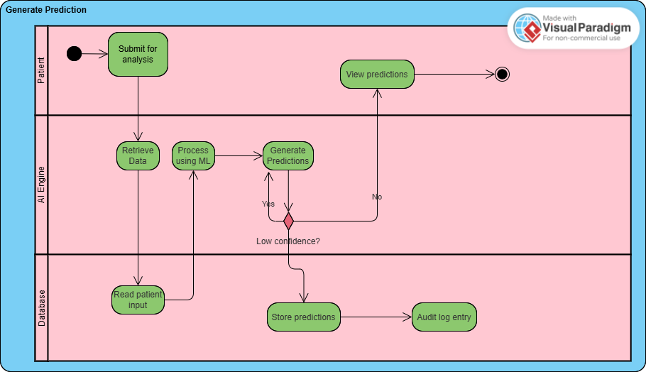

AD04: View Patient Reports (UC04)
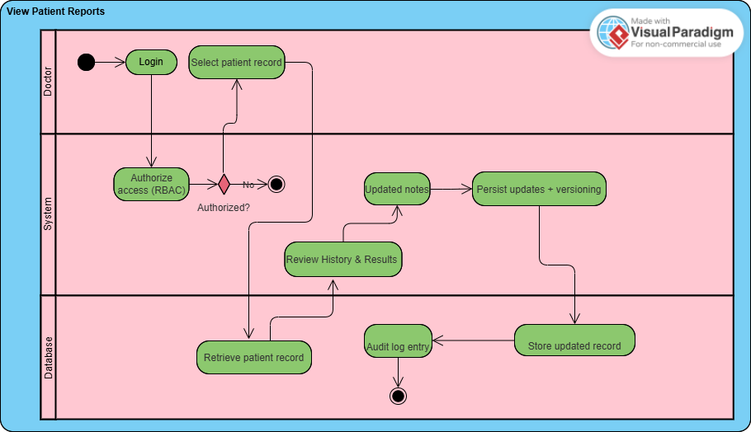

AD05: Store Health Records (UC05)
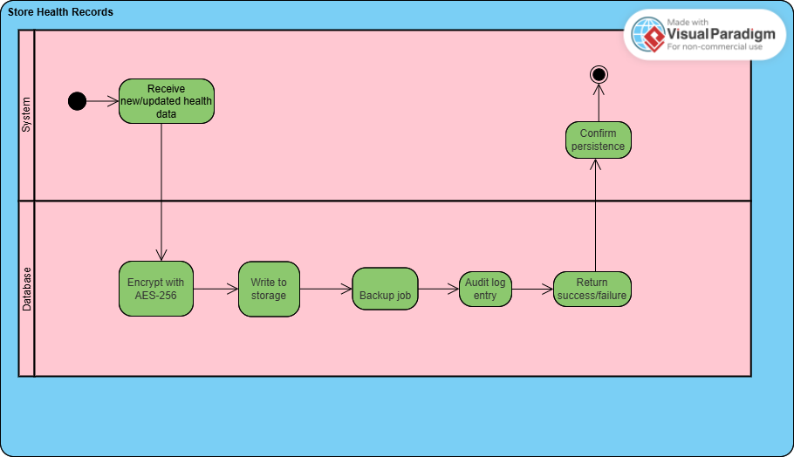

AD06: Manage Compliance (UC06)
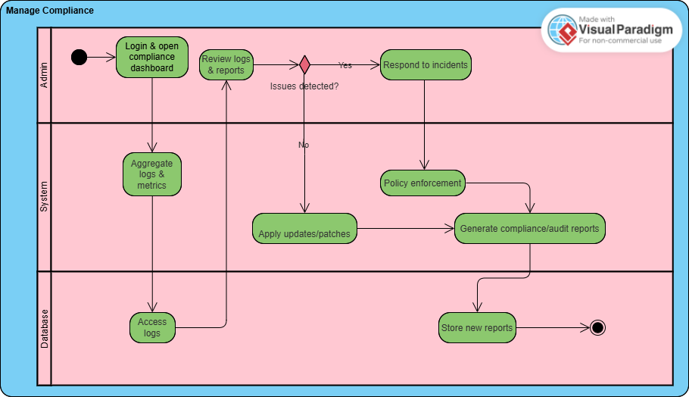

AD07: Manage User Accounts (UC07)
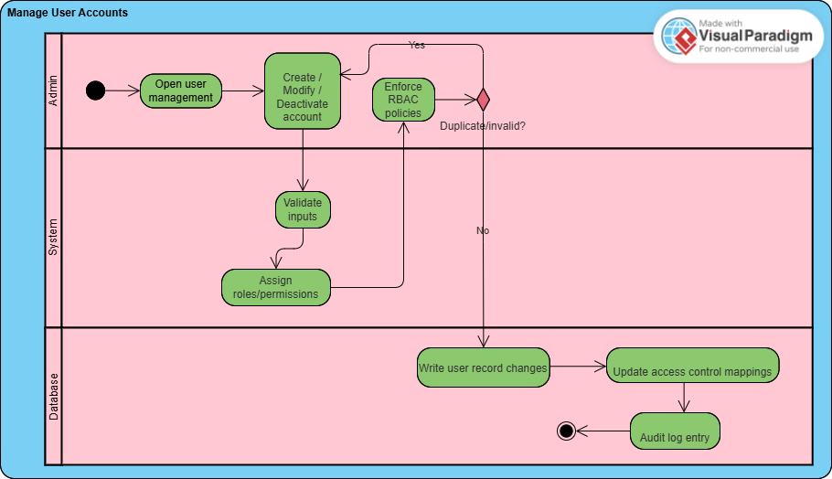

1.12 Traceability (initial)

FR | Description | UC | STD | AD | R / NFR / A
FR01 | Patients can register/login securely | UC01 | STD01 | AD01 | R01, R08, R09, R25, R33, R45, R46 / NFR03, NFR04, NFR06 / A01, A02, A06
FR02 | Patients input symptoms for AI analysis | UC02 | STD02 | AD02 | R02, R03, R06, R07, R22, R25 / NFR01, NFR04 / A01, A03
FR03 | Abnormal reading alerts to patients | UC03 | STD03 | AD03 | R06, R23 / NFR01 / A01
FR04 | Patients review AI predictions | UC03 | STD03 | AD03 | R04, R20, R23 / NFR01 / A07
FR05 | Patients update or correct previous data | UC02 | STD02 | AD02 | R07, R25 / NFR01 / A03
FR06 | Doctors view and edit patient reports | UC04 | STD04 | AD04 | R09–R13, R25, R28, R32 / NFR03, NFR02 / A04, A05
FR07 | Doctors annotate predictions with notes | UC04 | STD04 | AD04 | R11, R12, R25 / NFR03 / A04
FR08 | Alert doctors on low-confidence predictions | UC03, UC04 | STD03, STD04 | AD03, AD04 | R14, R23, R25 / NFR01 / A04, A07
FR09 | Maintain longitudinal patient data for trends | UC04, UC05 | STD04, STD05 | AD04, AD05 | R09, R13, R25, R32 / NFR02 / A05
FR10 | Doctors report incorrect predictions / issues | UC04, UC06 | STD04, STD06 | AD04, AD06 | R14, R38 / NFR02 / A04
FR11 | Generate possible disease predictions | UC03 | STD03 | AD03 | R17–R20, R23 / NFR01, NFR05 / A03, A07
FR12 | Continuously learn and refine predictions | UC03 | STD03 | AD03 | R18, R21 / NFR01 / A03
FR13 | Detect anomalies or incomplete data | UC02 | STD02 | AD02 | R22, R25 / NFR01 / A03
FR14 | Flag low-confidence predictions for review | UC03 | STD03 | AD03 | R23, R11, R14 / NFR01 / A04, A07
FR15 | Ensure prediction response < 2 s | UC03 | STD03 | AD03 | R18, R24 / NFR01, NFR05 / A01, A05
FR16 | Store patient data securely | UC05 | STD05 | AD05 | R25–R29, R32 / NFR03, NFR06 / A05, A06
FR17 | Apply AES-256 encryption to PHI | UC05 | STD05 | AD05 | R26, R25 / NFR03, NFR06 / A06
FR18 | Record DB operations in audit log | UC05, UC06 | STD05, STD06 | AD05, AD06 | R29, R35, R36 / NFR03, NFR06 / A06
FR19 | Perform automated backups and recovery | UC05 | STD05 | AD05 | R27, R31, R39 / NFR02 / A05, A09
FR20 | Retrieve and deliver data to front-end users | UC04, UC05 | STD04, STD05 | AD04, AD05 | R25, R32 / NFR01 / A05
FR21 | Admin create/modify/deactivate accounts | UC01, UC07 | STD01, STD07 | AD01, AD07 | R33, R34 / NFR03 / A08
FR22 | Assign role-based access rights | UC07 | STD07 | AD07 | R34, R28, R50 / NFR03 / A08
FR23 | Monitor HIPAA/PHIPA compliance | UC06 | STD06 | AD06 | R35–R37 / NFR03 / A06
FR24 | Conduct audits of system activity | UC06 | STD06 | AD06 | R36, R29 / NFR03, NFR02 / A06
FR25 | Generate compliance and audit reports | UC06 | STD06 | AD06 | R36, R41, R29 / NFR03, NFR02 / A09
FR26 | Apply patches, updates, and upgrades | UC06 | STD06 | AD06 | R39, R40, R41 / NFR02 / A09
FR27 | Validate and route incoming requests | UC01–UC07 | STD01–STD07 | AD01–AD07 | R43, R44 / NFR03 / A03
FR28 | Manage session control and tokens | UC01, UC07 | STD01, STD07 | AD01, AD07 | R45, R46 / NFR03 / A01
FR29 | Synchronize front-end and back-end data | UC02, UC03, UC05 | STD02, STD03, STD05 | AD02–AD05 | R43, R47 / NFR02 / A05
FR30 | Handle errors and show safe messages | UC01–UC07 | STD01–STD07 | AD01–AD07 | R48 / NFR03 / A01
FR31 | Log transactions and data exchanges | UC05, UC06, UC07 | STD05–STD07 | AD05–AD07 | R49 / NFR03, NFR06 / A06
FR32 | Enforce access control policies | UC01, UC04, UC07 | STD01, STD04, STD07 | AD01, AD04, AD07 | R50, R28 / NFR03 / A08
FR33 | Maintain uptime via failover mechanisms | UC06, UC07 | STD06, STD07 | AD06, AD07 | R39, R51 / NFR02 / A05, A09

